Practical –4

Practical Title: JavaScript DOM Manipulation, Event Handling, and UI Interactivity

Problem Definition: Add dynamic UI components such as collapsible FAQ, modal popup, image/content slider, notification banner, hamburger menu, and light/dark theme switcher using JavaScript.

Theory
References:https://developer.mozilla.org/en-US/docs/Learn_web_development/Core/Scripting/DOM_scripting

- How are DOM elements selected and modified?
Answer: DOM elements are selected using getElementById() and then their content or style can be changed using JavaScript.

2.Are event listeners attached correctly?
Answer: Yes, addEventListener() is used to perform an action when an event like a button click occurs.
3.Is localStorage used for remembering theme choice?
Answer: Yes, localStorage can save the selected theme and remember it even after the browser is closed and reopened.
4. Does interactivity improve usability without breaking accessibility?
Answer:Yes, simple interactive features make a webpage easier to use while keeping buttons and controls clear and accessible.

Implementation/ Output/Result
First, I am making a folder for save all files in one place and add all files into the folder and then I created code of HTML5 and then I add CSS in the code and also add for dynamic view like dark and light view for this javascript and run all files into the VS CODE and get output.

Evidence of Work (Screenshots)

Description: Figure 4.1 design of faq and model popup
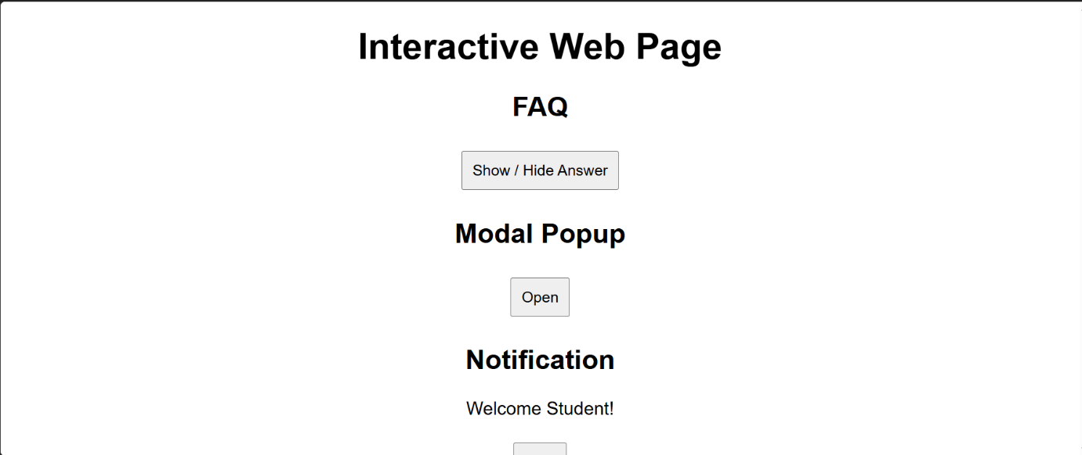
Description: Figure 4.2 notifications and theme


Description: Figure 4.3 dark page changes from theme


GitHub Repository Link:

Link: https://github.com/meetp2m/WDF-JAVASCRIPT-PRACTICAL4

Challenges Faced:

Answer: Understanding DOM manipulation and connecting JavaScript events with HTML elements was a little difficult.

F. Learning Outcomes:

Answer: I learned how to use JavaScript to make webpages interactive.
I also learned about DOM manipulation, event handling, and localStorage.

G. Faculty Remarks:

